**Practical Assignment – 5**

**1. Consider following observations/data. And apply simple linear regression and find out estimated coefficients b0 and b1. (Use numpy package) x= [0, 1, 2, 3, 4, 5, 6, 7, 8, 9, 11, 13] y = ([1, 3, 2, 5, 7, 8, 8, 9, 10, 12, 16, 18]**

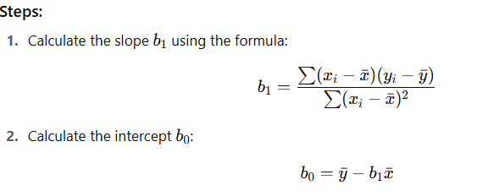

import numpy as np

import matplotlib.pyplot as plt

x = np.array([0, 1, 2, 3, 4, 5, 6, 7, 8, 9, 11, 13])

y = np.array([1, 3, 2, 5, 7, 8, 8, 9, 10, 12, 16, 18])

x_mean = np.mean(x)

y_mean = np.mean(y)

b1 = np.sum((x - x_mean) * (y - y_mean)) / np.sum((x - x_mean)**2)

b0 = y_mean - b1 * x_mean

print(b0, b1)

# Predicted values

y_pred = b0 + b1 * x

# Plot

plt.scatter(x, y, color='blue', label='Original data')

plt.plot(x, y_pred, color='red', label='Regression line')

plt.xlabel('x')

plt.ylabel('y')

plt.title('Simple Linear Regression')

plt.legend()

plt.grid(True)

plt.show()

**2. Consider following observations/data. And apply simple linear regression and find out estimated coefficients b1 and b1 Also analyse the performance of the model (Use sklearn package) x = np.array([1,2,3,4,5,6,7,8]) y = np.array([7,14,15,18,19,21,26,23])**

import numpy as np

from sklearn.linear_model import LinearRegression

from sklearn.metrics import mean_squared_error, r2_score

# Data

x = np.array([1,2,3,4,5,6,7,8]).reshape(-1, 1) #sklearn expects 2D input for X

y = np.array([7,14,15,18,19,21,26,23])

# Create and train the model

model = LinearRegression()

model.fit(x, y)

# Estimated coefficients

b0 = model.intercept_

b1 = model.coef_[0]

# Predictions

y_pred = model.predict(x)

# Performance metrics

mse = mean_squared_error(y, y_pred)

r2 = r2_score(y, y_pred)

print(f"Estimated intercept (b0): {b0}")

print(f"Estimated slope (b1): {b1}")

print(f"Mean Squared Error (MSE): {mse}")

print(f"R^2 score: {r2}")

**3. Consider the student data set It can be downloaded from: https://drive.google.com/open?id=1oakZCv7g3mlmCSdv9J8kdSaqO5_6dIOw Write a programme in python to apply simple linear regression and find out mean absolute error, mean squared error and root mean squared error.**

import numpy as np

from sklearn.linear_model import LinearRegression

from sklearn.metrics import mean_squared_error, r2_score

# Data

x = np.array([1,2,3,4,5,6,7,8]).reshape(-1, 1) #sklearn expects 2D input for X

y = np.array([7,14,15,18,19,21,26,23])

# Create and train the model

model = LinearRegression()

model.fit(x, y)

# Estimated coefficients

b0 = model.intercept_

b1 = model.coef_[0]

# Predictions

y_pred = model.predict(x)

# Performance metrics

mse = mean_squared_error(y, y_pred)

r2 = r2_score(y, y_pred)

print(f"Estimated intercept (b0): {b0}")

print(f"Estimated slope (b1): {b1}")

print(f"Mean Squared Error (MSE): {mse}")

print(f"R^2 score: {r2}")